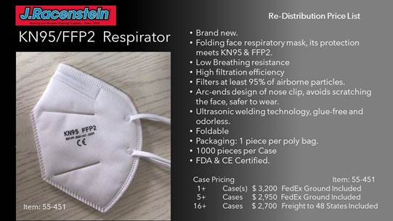

Doug Apt

Senior Sales Manager/Product development

J.Racenstein Company

(800) 221-3748 ext.107

(201) 809-7505 Desk Direct