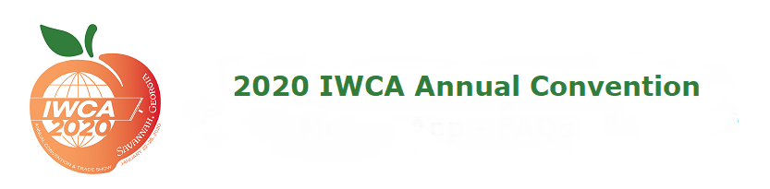

Silent Auction Donation Form

Please submit donation forms for all items no later than January 23,2020. This will allow us to better plan display space in the Banquet and prepare necessary paperwork in advance providing a smoother experience on-site. As an added incentive for all donation forms received by the deadline, donors will be listed and thanked in the on-site signage.

Fields in bold are required. Name of Individual Donor or Donating Company:
Donor Address:
City, State/Province, Zip: Country:
Donor Phone: Email:

# of Items | Item Description | Fair Market Value Per Item | Total Value

Special Instructions:

All items for the silent auction must either be hand-carried to the convention or shipped directly to the hotel, not to arrive earlier than
Friday January 17, 2020. The shipping address is as follows:
Hyatt Regency Savannah
HOLD FOR GUEST: (Guest Name) (Guest Cell Phone) IWCA Silent Auction – January 25, 2020
2 W. Bay St.
Savannah, GA 31401
Box of

