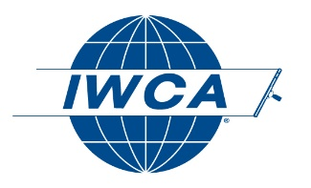
2020 IWCA FELLOWSHIP AWARD
NOMINATION FORM

To submit a nomination for the IWCA Fellowship Award, please complete this form and return to the IWCA offices no later than November 22, 2019. You may type directly in the fields below, save and email to info@iwca.org, or print this form to fax or mail.
_____________________________________________________________________________________________

Your name:

Date: I am a member of the IWCA in good standing.
______________________________________________________________________________

CANDIDATE NAME:

COMPANY NAME:

Please provide three to five examples of ways in which this individual has shown themselves to be an ideal candidate to receive the IWCA Fellowship Award.

In summary, this candidate should receive the IWCA Fellowship Award because:

_____________________________________________________________________________________

